**WIREFRAMES (SCREEN MOCKUPS)**

CREATED USING WWW.WIREFRAME.CC

**LOGIN SCREEN**

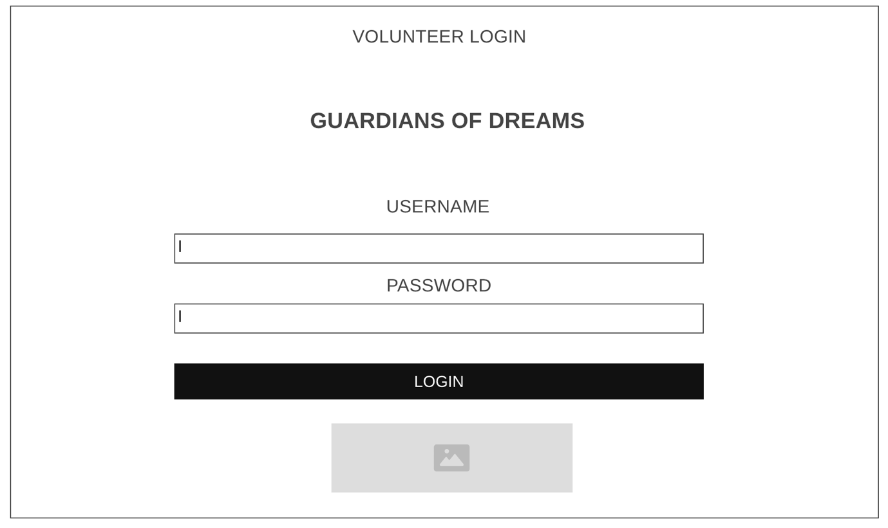

**PROFILE PAGE**

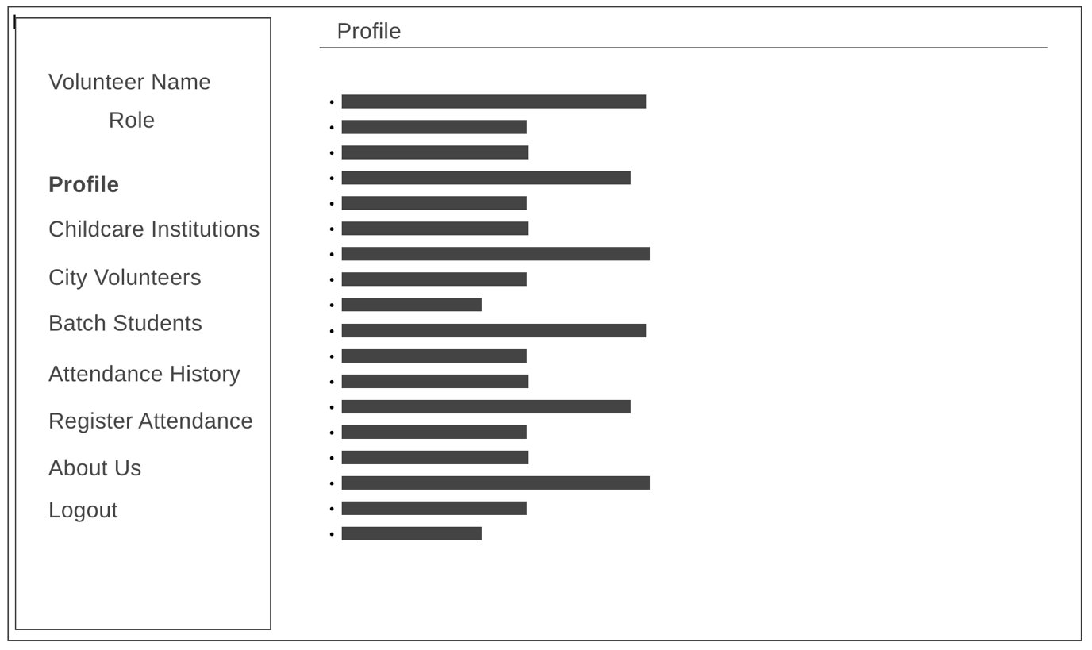

**CHILDCARE INSTITUTIONS PAGE**

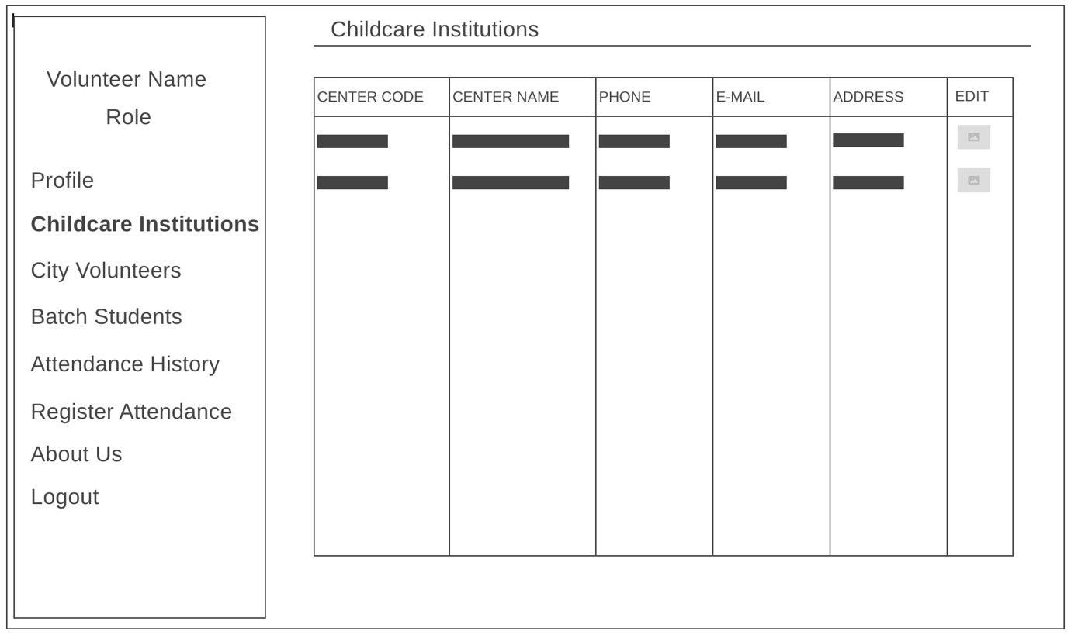

**EDIT CHILDCARE INSTITUTION PAGE**

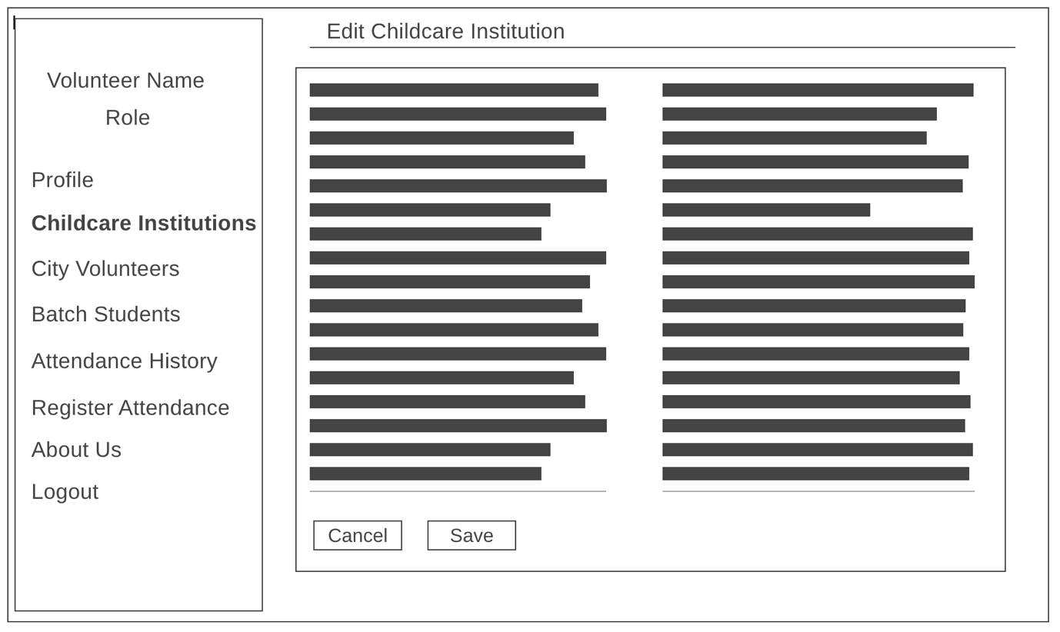

**CITY VOLUNTEERS PAGE**

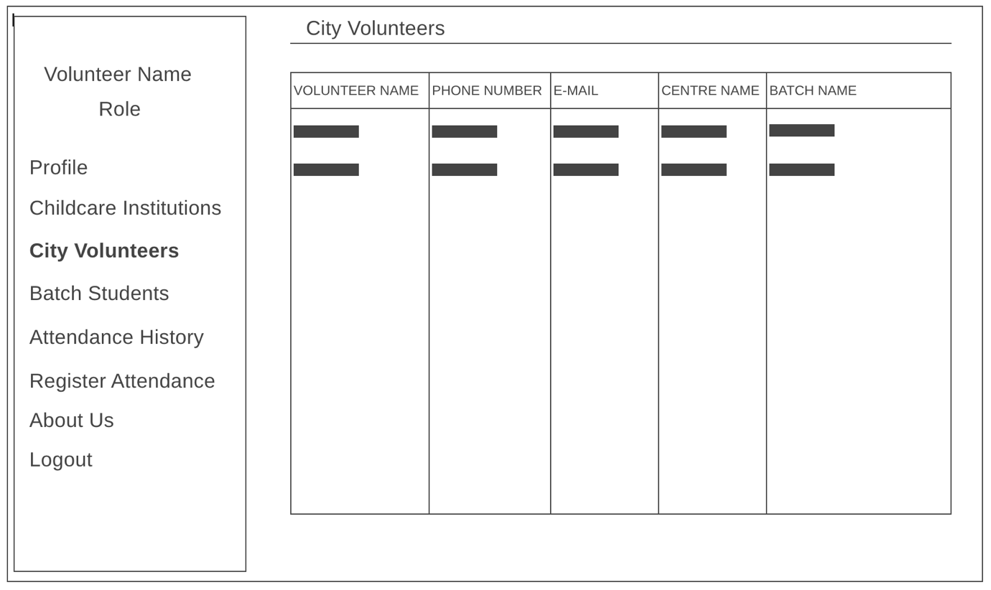

**BATCH STUDENTS PAGE**

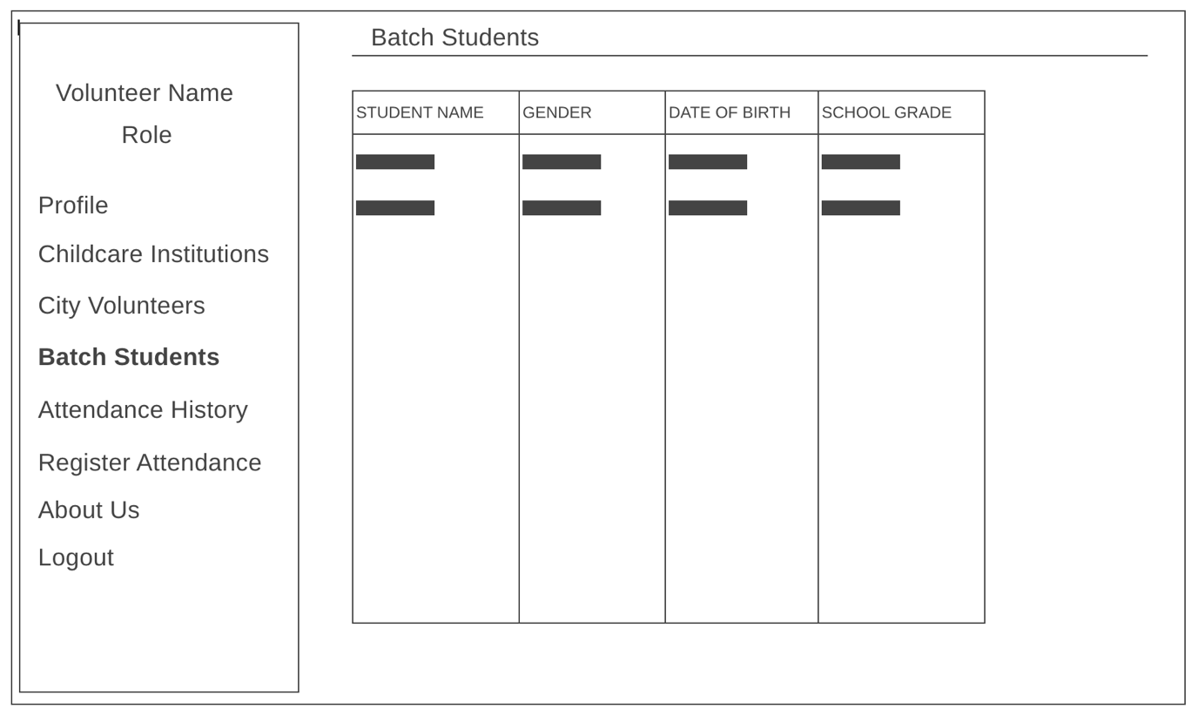

**ATTENDANCE HISTORY PAGE**

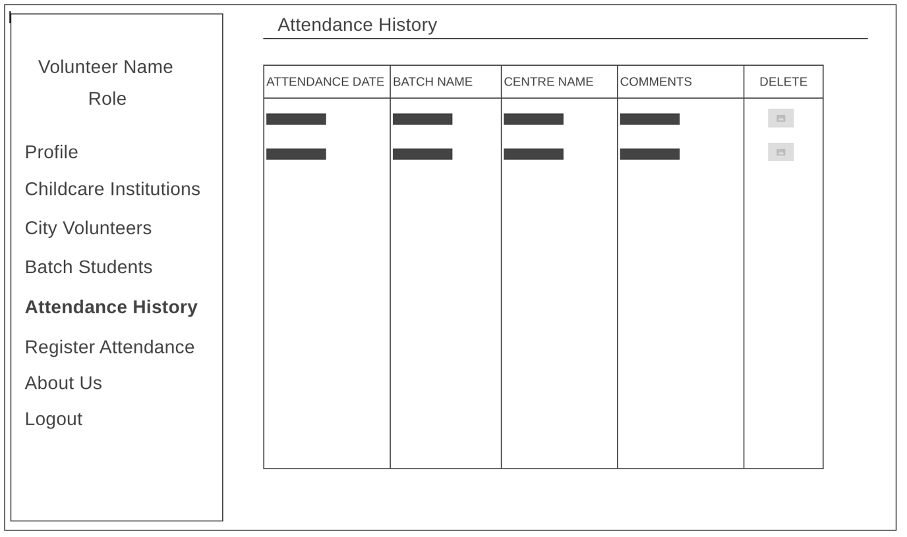

**REGISTER ATTENDANCE PAGE**

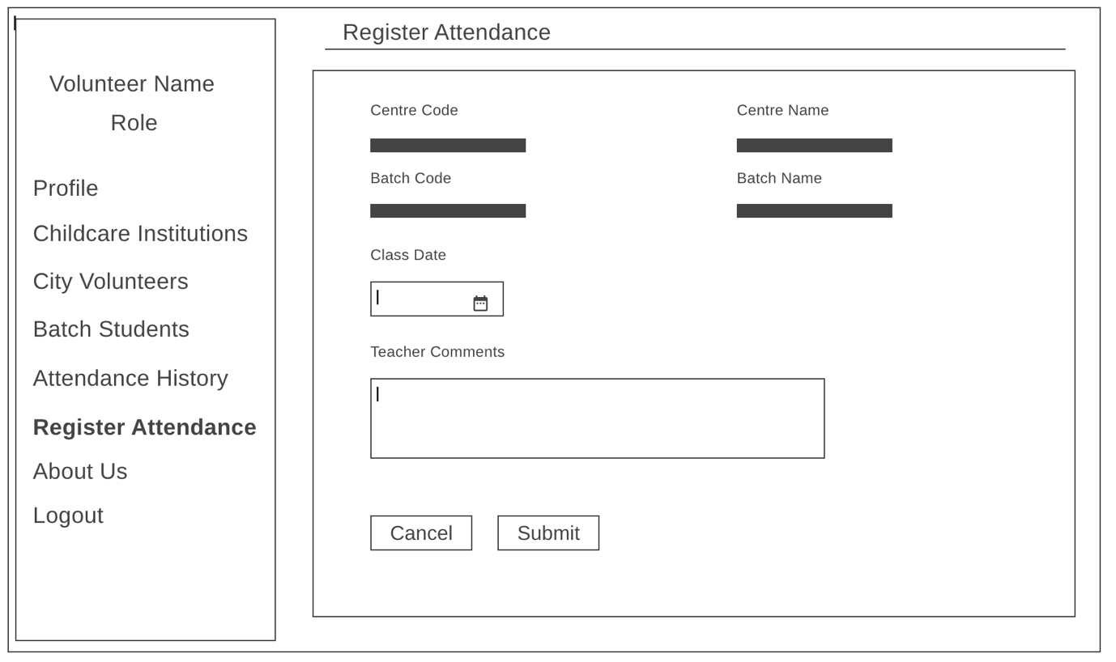

**ABOUT US PAGE**

